MARS Simulations and Field Measurements for the A2B7 Beam Loss Case at the Accumulator
February 26, 2013

f

Tony Leveling
Fermi National Accelerator Laboratory
- Introduction
The development of a Total Loss Monitor (TLM) detection system to be used as a Radiation Safety System requires a thorough understanding of the relationships between TLM response in the beam enclosure and the dosimetric quantity of concern which may include radiation effective dose on the surface of a shielding berm; activation of ground water, surface water, or air; production of residual activation in the beam enclosure; or radiation effective dose at the exit of a labyrinth or penetration. The purpose of this document is to report on the relationship between TLM response and radiation effective dose at the A2B7 magnet location of the Accumulator/Debuncher Ring.
In this document, the results of field measurements and of MARS calculations are reported. Measurements include radiation effective dose on the surface of the A2B7 shielding berm and TLM response in the Accumulator/Debuncher beam enclosure. MARS calculations include radiation effective dose, radiation dose and radiation weighting factor outside the shielding berm at A2B7. Additional MARS calculations include energy deposition in TLMs for a beam loss on the A2B7 magnet, a beam loss on a 1” diameter, Fe rod located in a fictitious beam enclosure lined with TLMs, and a beam loss on 24” diameter, Fe rod, also located in a fictitious beam enclosure lined with TLMs.
In the MARS calculations presented here, the TLM detector is modeled fictitiously as a tissue equivalent cylinder, 15.24 (6”) in diameter and 15 meters long. The sole purpose of modeling the TLM detectors in this way is to obtain a statistically significant, relative response of TLM detector arrays in tunnel enclosures. The objective is to provide a practical way to understand TLM response for variable tunnel/accelerator/beam line component geometries. The modeling of the physical detector with actual materials, gas, and applied bias is left for future work.
- Radiation Effective Dose Measurement on Shielding Berm Above A2B7
The A2B7 magnet is the first major bending magnet encountered by the beam during reverse proton injection into the Accumulator storage ring. When the Accumulator bending magnet power supply is de-energized, beam injected into Accumulator storage ring is lost entirely in the A2B7 magnet. An array of Chipmunks arranged on the shielding berm above the A2B7 magnet location has been used to measure the resulting radiation effective dose on the Accumulator/Debuncher shielding berm resulting from this beam loss. This measurement was first made for the controlled beam loss condition in 2000 for the pbar shielding assessment and has been repeated many times in 2011 and 2012 for the development of the TLM system.
The array of 5 chipmunks was placed at 5 foot intervals on the berm surface, beginning at the mid-point of A2B7 and along the central axis of the A2B7 magnet aperture. DUSAF coordinates derived from magnet alignment data and facility construction data were used to establish detector positions. The local reference points on the A20 berm are two site risers with DUSAF coordinates whose positions were established during the beam enclosure construction. Chipmunk data, both background and signal data, was recorded by lumberjack along with proton intensity. The result of the measurement made for the 2000 assessment in shown in Figure 1. The Quality Factor (now radiation weighting factor) was measured by ES&H Section personnel and was found to have a value of 1 [1]. The resulting peak dose rate on the berm normalized to a loss condition of 3.6E13 protons per hour was found to be 0.26 mrem per hour.
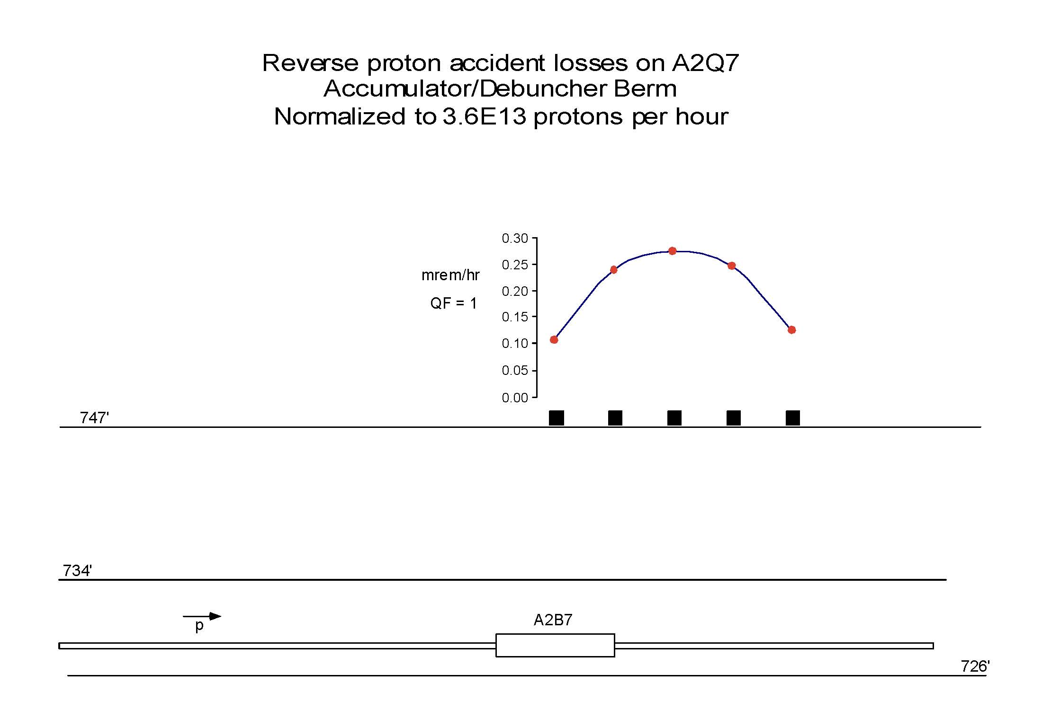
Figure 1: Pbar Shielding Assessment – 2000 measurement of dose equivalent as function of 8 GeV beam loss

A chipmunk array, identical to the one used for the 2000 shielding assessment for A2B7, was reestablished in October 2011 to be used in conjunction with TLM response measurements. Dozens of controlled beam loss measurements were made from October 2011 through April 2012. Data from a set of 10 measurements collected in April 2012 is averaged and displayed in Figure 2 along with the original measurement data obtained in 2000. The quality factor used in the 2000 shielding assessment (QF=1) is used. As expected, the result of the recent measurement is similar to the one made for the 2000 shielding assessment.

Figure 2: Comparison of measurements made on shielding berm at A2B7 on March 13, 2000 and on April 11, 2012. The Quality Factor measured during the 2000 shielding assessment is applied to the April 2012 measurement.
- MARS calculation at Shielding Berm Above A2B7
A MARS model of the Accumulator tunnel at the A2B7 magnet was created to predict the radiation effective dose rate on the surface of the shielding berm for comparison with measurement data. The MARS model was accurately constructed from consideration of DUSAF coordinates for the beam enclosure (Figure 3) along with site coordinates for the A2B7 magnet. The magnet modeled is an SDB dipole except that the sagitta was omitted for simplicity. An engineering drawing showing the magnet lamination detail is shown in Figure 4. No magnetic field is modeled since the beam measurements where made with the bend bus de-energized.
Figure 3: Accumulator/Debuncher Ring Structural Concrete Drawing from which the tunnel geometry for the MARS calculation was derived. DUSAF coordinates and other layout parameters were used to correctly place the A2B7 SBD magnet with the enclosure.
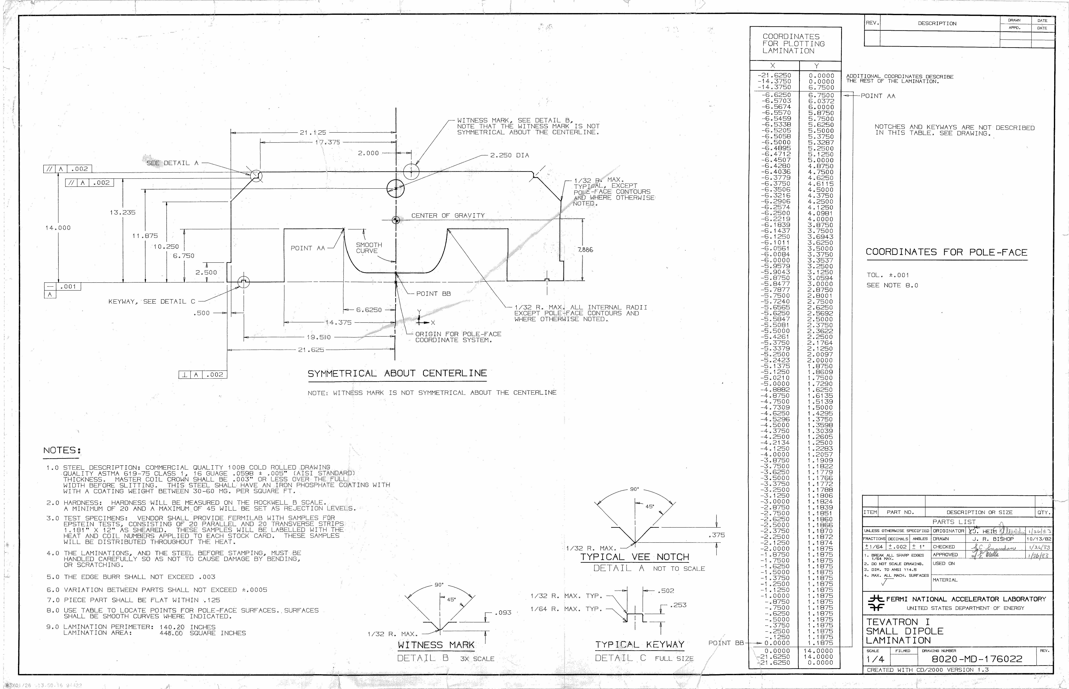
Figure 4: Engineering drawing of the SBD magnet lamination used in the construction of the MARS model.
For this MARS calculation, the berm soil is modeled as ‘GTIL’ from the standard list of materials which has a density of 2.4 g/cc. The density of GTIL was adjusted to 2.24 g/cc, the established laboratory standard. The total thickness of the shielding berm is 13 feet which includes a 1 foot thick concrete tunnel ceiling.
In addition to the tunnel, magnet and shielding berm, an array of detectors representing TLMs was included in the model to predict the energy deposition as a function of position around the tunnel enclosure. The TLMs are modeled as tissue equivalent cylinders, 15.24 cm in diameter and 15 meters in length. Figure 5 shows various cross sections of the geometry used. The beam trajectory used in the model is derived from the relative positions of ELAM and A2B7 which in turn are based upon the DUSAF coordinates of those magnet positions. The resulting beam interaction point shown in Figure 5 closely approximates the beam interaction point determined with an LSM shortly after a period of running high intensity study pulses into the A2B7 magnet. The MARS.INP, GEOM.INP, MATER.INP files used in the MARS calculations are included in Appendices 1, 2, and 3 of this document.
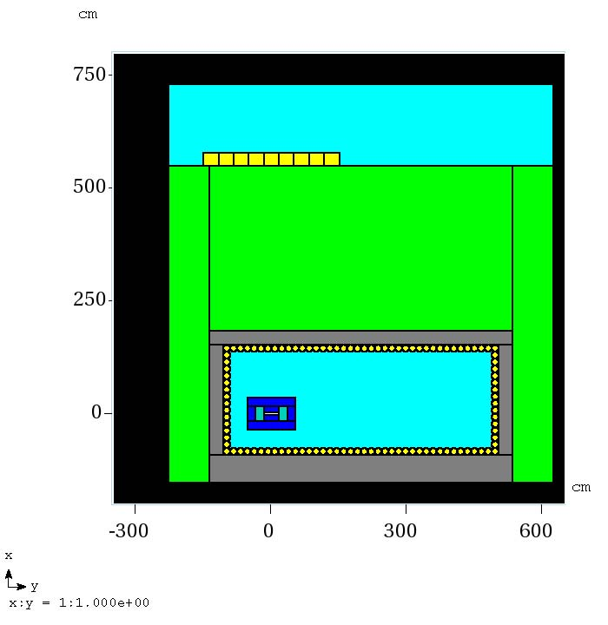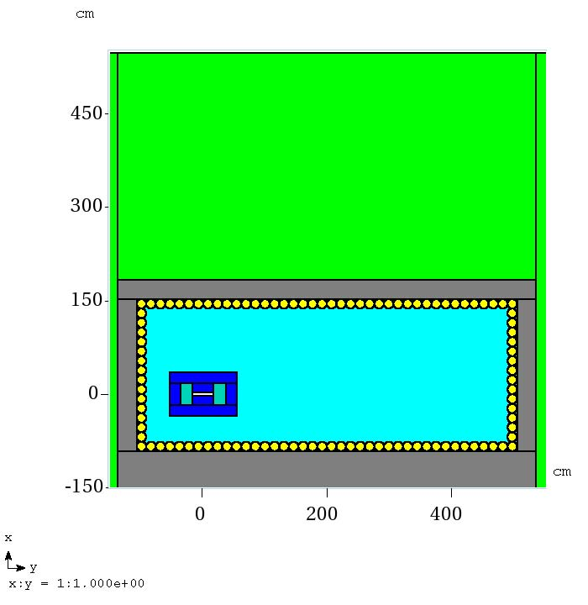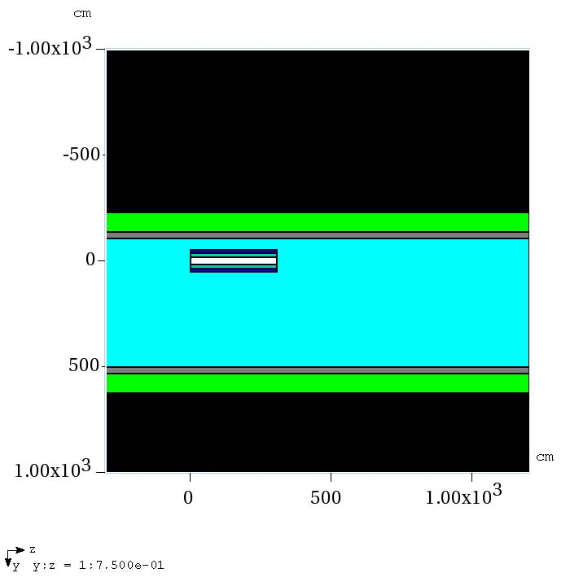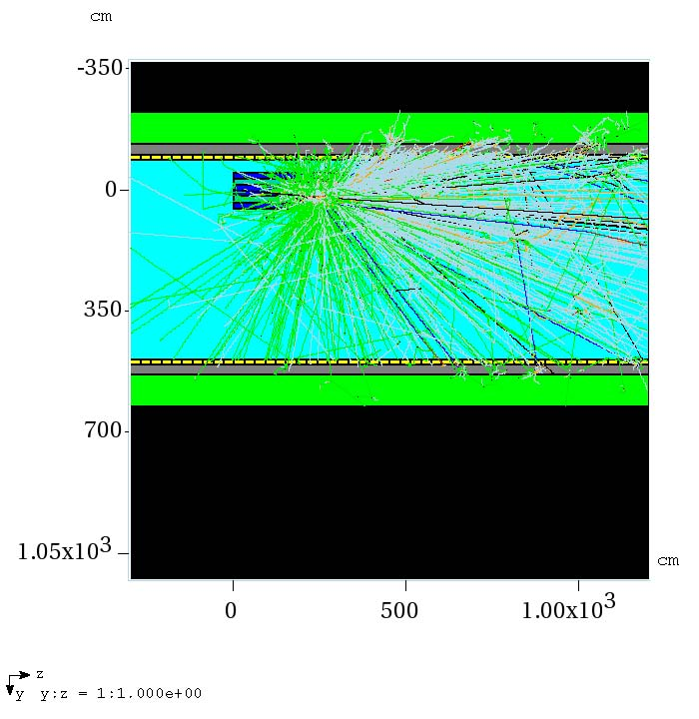
Figure 5: MARS GUI images for the A2B7 calculation. Starting from the top left, the model elevation cross section is show through the A2B7 magnet; a enlarged view of the tunnel elevation section with improved magnet and TLM resolution; a plan view of the model through the horizontal plane at beam center; and a plan view showing the particle shower tracks.

A histogram of the resulting radiation effective dose calculation, normalized to 3.6E13 protons/hour is shown in Figure 6. The histogram represents a tissue equivalent detector array on the surface of the berm above the A2B7 magnet.
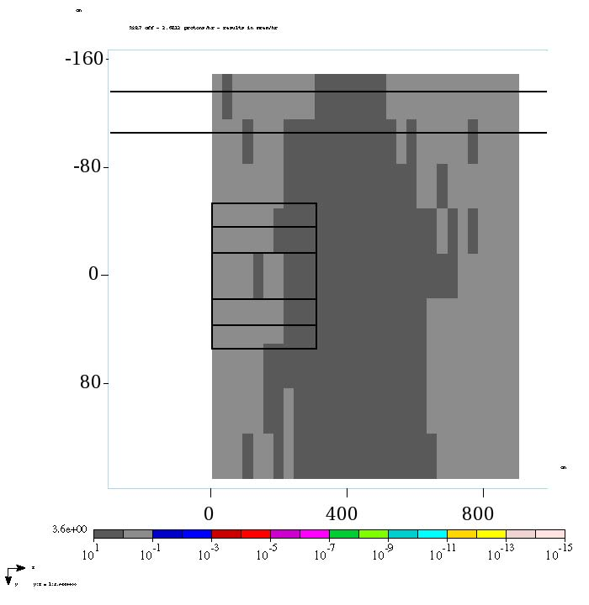
Figure 6: MARS histogram of detector array on A2B7 shielding berm. The result (mrem/hr) is normalized to 3.6E13 protons/hr.
The results of the MARS calculation can be compared with the results of the shielding measurements made in April 2012. To simplify the comparison between calculation and measurement, the resulting energy deposition in GeV/g from MARS is converted to dose (mrads) and the measurement from the April 2012 is reported with a quality factor of 1, essentially in terms of dose (mrads). An average value of dose is obtained from 3 center bins across the beam trajectory. The calculated and measured dose is shown graphically in Figure 7. The MARS result is in agreement with the measurement within a factor of 2.

Figure 7: Comparison of MARS calculation of dose (mrad) with April 2012 measurement. Indicated error bars are statistical errors reported by the MARS calculation.

The radiation weighting factor used in the effective dose calculation by MARS can be determined by dividing the calculated effective dose by the calculated dose. Figure 8 shows the radiation weighting factor as a function of position along the berm surface.

Figure 8: Radiation weighting factor from the MARS calculation using GTIL with a density of 2.24 g/cc for the shielding berm is obtained by dividing radiation effective dose by radiation dose. Error bars are statistical. The average radiation weighting factor is 6.2.

The MARS calculation is very sensitive to the choice of type and density assigned to the shielding berm. To illustrate the point, Figure 9 shows the results of two MARS calculations in which soil with a density of 1.9 g/cc and glacial till with a density of 2.24 g/cc was used; the models are identical in every other way. The actual density of the particular soil on the Accumulator/Debuncher shielding berm has not yet been determined.

Figure 9: A comparison of MARS results for the A2B7 controlled beam loss. The only difference between the two calculations is the choice of soil type and density for the shielding berm.

The result of the MARS radiation effective dose calculation is compared with the measurement result in Figure 10. The radiation weighting factor from the MARS calculation is applied to the radiation dose measurement for comparison. The laboratory recommendation for the density of the earth berm, 2.24 g/cc was used in the calculation for comparison with the measurement. earth berm density The MARS calculation and measurement of radiation effective dose agree within a factor of 2.

Figure 10: The result of the calculated radiation effective dose is compared with the measurement. The calculated average radiation weighting factor (6.2) is applied to the radiation dose measurement.
- TLM Response at A2B7
A number of TLMs including 125’, 250’, and 338’ detectors were installed starting at or under the AP30 service building and ending in the A20, depending upon their respective length. The shortest detector extended well beyond the end of the A2B7 magnet to ensure the entire beam shower was represented in the response. A bias voltage, applied to the outer conductor ranging from 0 to 2000 volts was applied. Beam intensity was delivered at three nominal intensities spanning 2 decades. The purpose of these series of measurements was to determine an operating point for the bias voltage which would provide reasonably flat, linear response across a wide range of beam loss. The measurements were made with either the so called “blue box”, a chipmunk electrometer, or a Keithly 6517B. The resulting quantity from the measurement is given in units of charge (typically, nanocoulombs (nC)). The result of these measurements for the three TLMs is shown in Figures 13, 14, and 15. The TLM response, regardless of TLM length, with an applied bias voltage of 500 volts is about 3 nC/E10 protons at 8 GeV.
The position of the 125’, 250’, and 338’ TLMs relative to the A2B7 magnet are shown in Photograph in Figure 11. A sketch shown in Figure 12 show the location of the TLMs based upon field measurements.
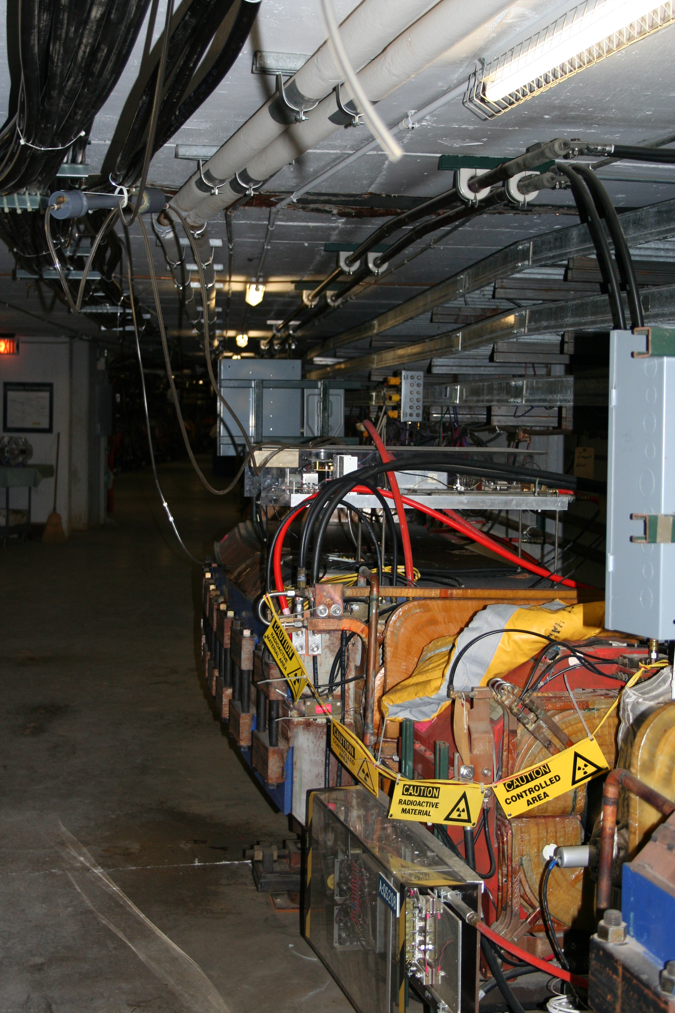
FIGURE 11: Accumulator/Debuncher Ring looking upstream at the A2B7 magnet. TLMs are indicated by red arrow in the photograph.
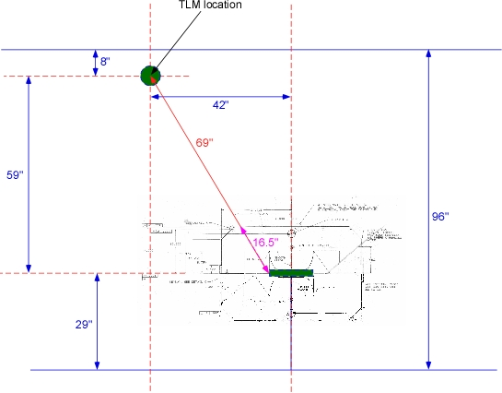
Figure 12: The 125’, 250’, and 338’ TLM positions with respect to A2B7 for all TLM response measurements is shown in this tunnel layout sketch. The TLMs are approximately 69” from the beam interaction point and the steel/coil thickness between the loss point and the TLM is 16.5”.
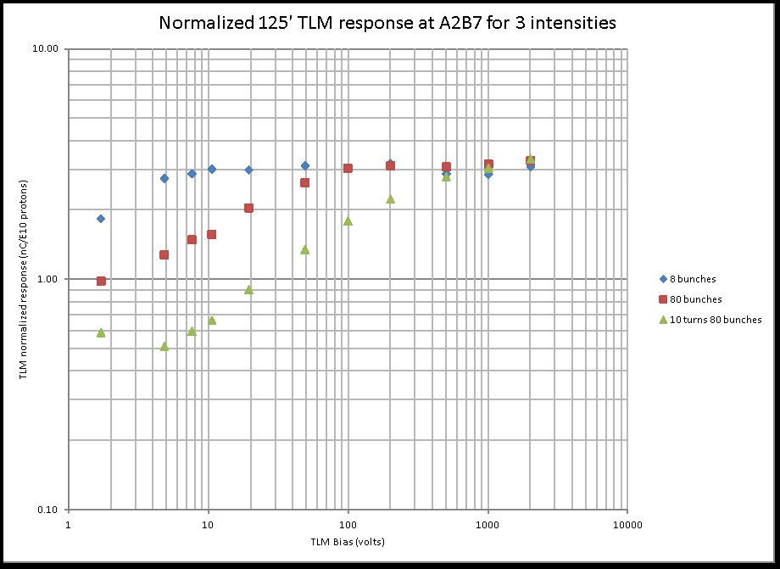
Figure 13: 125 foot TLM response, normalized to beam intensity over two decades as a function of bias voltage.

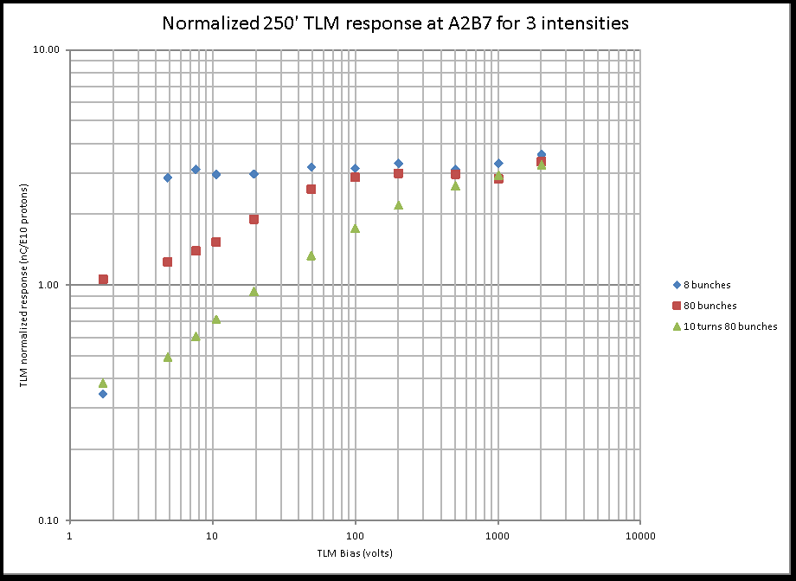
Figure 14: 250 foot TLM response, normalized to beam intensity over two decades as a function of bias voltage.

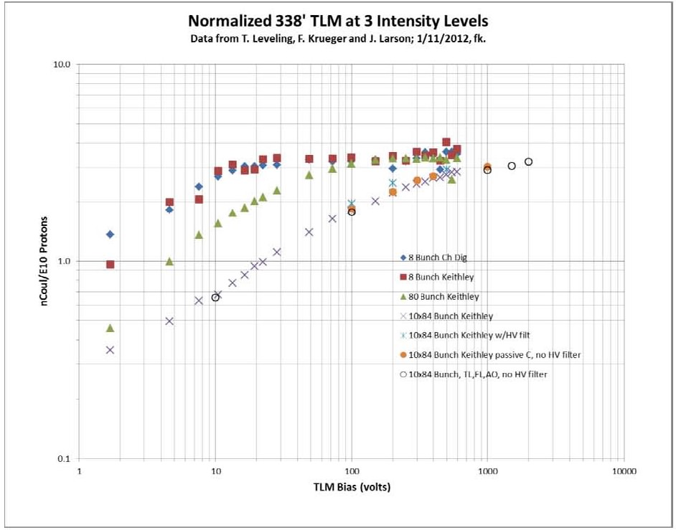
Figure 15: 338 foot TLM response, normalized to beam intensity over two decades as a function of bias voltage.

- MARS Calculation of TLM Response at A2B7
The TLM detectors modeled are 15.24 cm diameter, 15 meter long tissue equivalent detectors. The individual detectors are subdivided into 50 bins, each 30 cm long. Energy deposition in GeV/g/p was determined for each detector bin. The purpose of this modeling effort was to determine the relative response of a TLM with respect to position within the tunnel for the A2B7 beam loss.
In Figure 16, the summation of energy deposition for each TLM and the maximum bin response of each TLM are shown.

Figure 16: Energy Deposition sum and maximum bin for 108 TLMs. The groups from left to right are beam left wall, beam right wall, tunnel floor, and tunnel ceiling.
It is also of interest to look at the TLM total response as a function of position around the beam enclosure. Figure 17 shows TLM group responses by position, i.e., beam left wall, beam right wall, floor and ceiling. The variation in magnet steel between the beam loss location and the relative TLM positions has an impact on the TLM response.

Figure 17: TLM total response as a function of group and location. The irregular geometry of the A2B7 magnet mass relative to TLM position introduces self-shielding effects in the TLM response. The position of the 125’, 250’, and 338’ TLMs installed in the Accumulator/Debuncher ring is also indicated for reference.
One can gather from Figure 17 that TLM response is not just dependent upon distance from the beam loss point. The bimodal response for some of the indicated points is assumed to be due to differences in the intervening steel thickness between the beam loss point and the TLM positions. The direction cosines of the incident beam may also play a role, but this has not been explored.
Two additional MARS calculations were made to separate the impacts of distance and shielding seen in the A2B7 case. In the first run a 17 foot diameter concrete tunnel is modeled and is lined with 96 tissue equivalent detectors which are meant to emulate TLM response. A 1 inch diameter rod is placed off center in the tunnel at 7.5 feet making the TLM distance vary from 1 to 16 feet. An image of the model and of the model with a few particle tracks are shown in Figure 18.
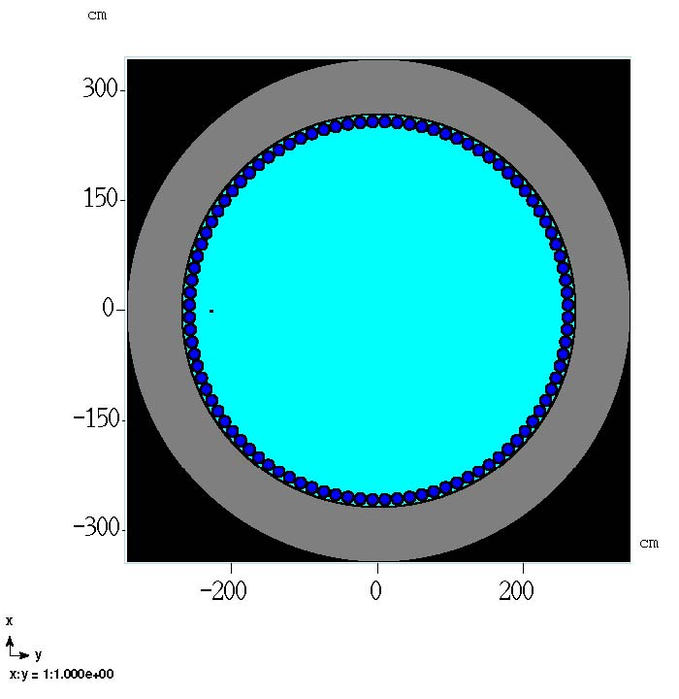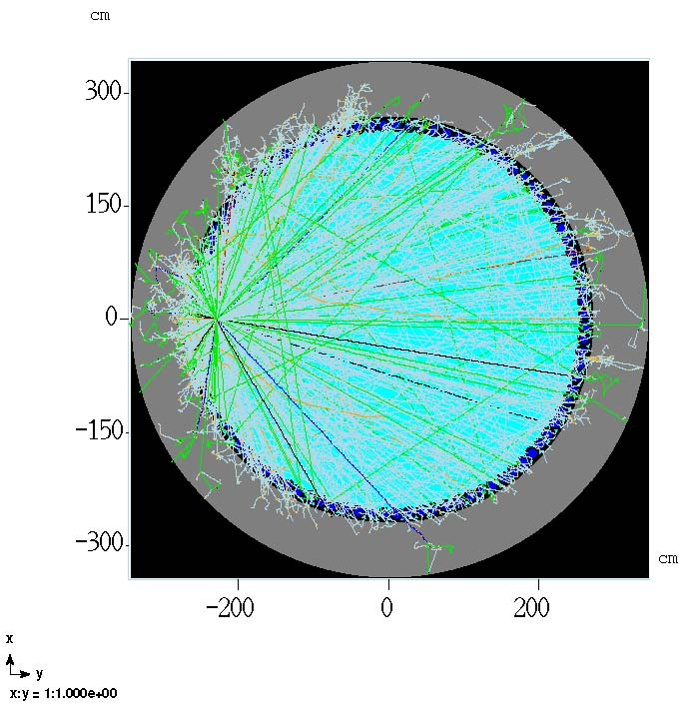
Figure 18: MARS model of cylindrical beam enclosure with a 1” diameter steel target rod 48” in length is shown at left. At right is the same model with particle tracks from a few incident 8 GeV protons. The TLM detector numbering begins with detector 1 just past 12 o’clock and continues clockwise with detector 96 just before 12 o’clock.
The model is 27 meters long and the TLM detectors are subdivided into 45 cm bins. The total TLM response and the response of the maximum bin from each of the 96 detectors is shown in Figures 19 and 20.

Figure 19: TLM response as a function of distance from a 1” diameter, 4’ steel rod. The response at a distance of 8’ in this calculation agrees well with the 1” steel response in Figure 20.

Figure 20: Peak TLM bin response as a function of position in the tunnel geometry. Natural pairs of detectors are present due to model symmetry.
Figure 19 indicates that the total response of individual TLMs varies with distance as 1/r. Figure 20 indicates that the peak bin response of individual TLMs varies with distance as 1/r^{1.75} . The smooth functions shown in Figures 19 and 20 indicate that in the presence of uniform steel thickness, a regular relationship with distance results.
In a second MARS run, the effect of shielding thickness on TLM response is modeled. The same 17’ tunnel and detector geometry is used. A 24” diameter Fe target, 48” long is placed off center in the tunnel with the steel center 11” right of the center. Beam is targeted on the tunnel center so shielding thickness between the beam loss point and the TLM varies over the range of 1 to 23 inches. All TLMs are 8’ from the center of the tunnel. The cross section view of the model with and without particle tracks is shown in Figure 21.
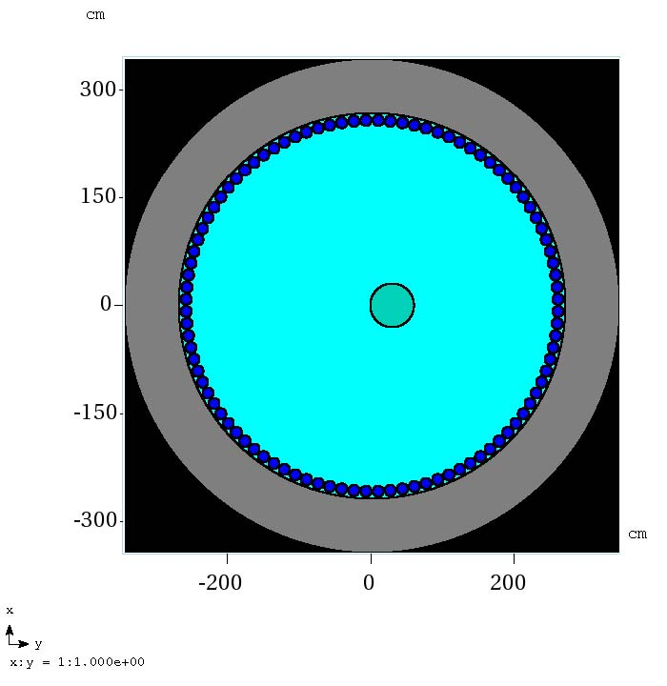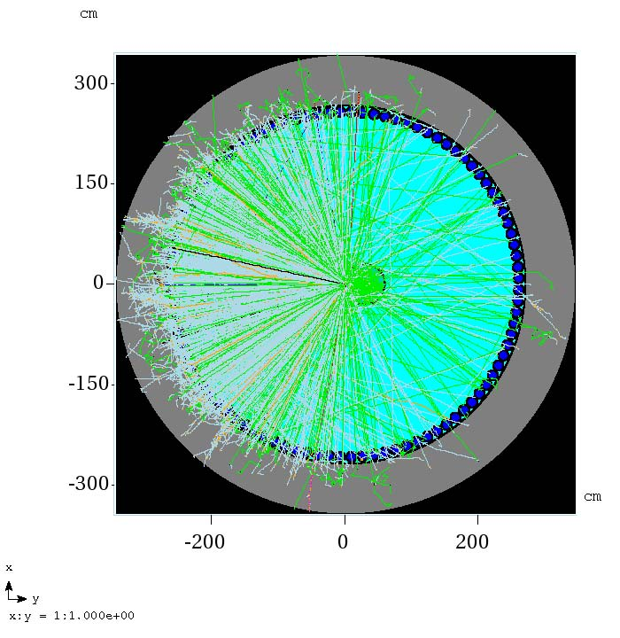
Figure 21: MARS model of cylindrical beam enclosure with a 24” diameter steel target rod 48” in length is shown at left. At right is the same model with particle tracks from a few incident 8 GeV protons. The TLM detector numbering begins with detector 1 just past 12 o’clock and continues clockwise with detector 96 just before 12 o’clock.
The shielding thickness varies for each detector as shown in Figure 22.

Figure 22: TLM detector shielding varies as a function of position with the cylindrical tunnel from 1 to 23 inches.
The total response of TLMS as a function of intervening shield thickness is shown in Figure 23. The response of the maximum bin for each TLM is shown in Figure 24. The dependence of TLM response on the distance between itself and the beam loss point is significant and should be considered in the development of TLM trip point settings.

Figure 23: TLM total response as a function of shield thickness. The response at a shield thickness of 1”, (all points are 8 feet from the beam loss point in this figure) agrees well with the 1” diameter steel rod response in Figure 19.

Figure 24: Peak TLM bin response as a function of beam loss point shielding thickness.
The smooth functions shown if Figures 21 and 22 indicate that when the distance between the TLM and beam loss point is constant, a varying shield thickness results in a predictable TLM response. The dependence of steel thickness between the TLM and the beam loss point is significant and must be considered in the development of TLM trip point settings.
- Discussion
The setting of a trip level for a TLM electrometer connected to a detector located in a delivery ring arc requires that one determine the most limiting radiological condition. First, suppose the limiting condition is 1 watt per meter in order to control residual radiation dose rates to workers within the beam enclosure during maintenance periods. A Delivery Ring arc has a typical length of about 117 meters. It follows that a total beam loss equivalent to 117 watts distributed over the arc is the limit. A watt/meter of beam power at 8 GeV is 7.8E8 protons/m/s. The total beam loss over the arc must be limited to about 9.1E10 protons/second. Assuming A2B7 beam loss is representative of the most limiting condition (3 nC/E10 protons), the amount of charge produced in a TLM electrometer would be 27.4 nC/s.
A TLM detector cannot distinguish between a distributed beam loss and one that is localized at a specific location such as A2B7. Scaling from the findings in section 4 above, a total beam loss of 9.1E10 protons per second at A2B7 would produced an effective dose rate on the berm surface of about 11 mrem/hr. Thus, a TLM trip level set to limit average losses to 1 watt/meter would require radiological postings on the shielding berm to remain within limits of the FRCM. Now suppose that a limiting dose rate of 0.25 mrem/hr is chosen for the Debuncher Arcs at a location such as A2B7. Scaling from the measurement data of Figure 8, a beam loss rate of 2E9 protons/second at a single location would require a trip level of 36 nC/minute. Finally, the trip level should be scaled for distance and intervening shield thickness as suggested by the work described in Section 5 above.
- Summary
The radiation effective dose outside of a shielding berm resulting from a controlled beam loss on the A2B7 magnet has been measured. The result of this measurement has been compared with a MARS calculation using the existing tunnel geometry. The response of various TLMs to the same controlled beam loss has been measured. Results of MARS calculations have been reported to enable predictions of TLM response as a function of distance from a beam loss location and as a function of varying steel thickness. A method of determining the trip level for a TLM electrometer connected to a detector in the Accumulator/Debuncher tunnel arcs has been described.
- References
- Pbar Shielding Assessment – 2000, http://www-bdnew.fnal.gov/pbar/documents/Antiproton%20Source%202000%20Shielding%20Assessment/Antiproton%20Source%202000%20Shielding%20Assessment.htm
- N.V. Mokhov, “The MARS Code System User’s Guide”, Fermilab-FN-628 (1995); N. V. Mokhov, S. I. Striganov, “MARS15 overview,” Proc. Hadronic Shower Simulation Workshop, Batavia, Illinois, USA, 6-8 September, 2006, Vol. 896, pp. 50-60, American Institute of Physics, Melville, NY (2007); http://www-ap.fnal.gov/MARS/

MARS.INP file
A2B7 TLM response 01/9/13

INDX T 3=T 5=T

CTRL 1
C RZVL 545. 600. 5=1.E8
C TAPE 18

NEVT 750000 50

ENRG 8.

IPIB 1 2
BEAM 0.2 0.2
INIT 0. 0. 0. 0. 0.087155 0.996195

C SMIN 1.E-3 5.
NLNG 1
ZSEC 1200.
NLTR 1
RSEC 1000.
ZMIN -300.
MATR 'MATER.INP'

NHBK 1

STOP
*MCNP START
m1 26000 1.0 cond=1
m2 29000 -0.51738 1001 -0.054004 8016 -0.428616
m3 1001 -0.1077 6000 -0.1283 8016 -0.7266 7014 -0.0374
m4 1001 -0.006 6000 -0.030 8016 -0.500 11023 -0.010 13027 -0.030 &
14000 -0.200 19000 -0.010 20000 -0.200 26000 -0.014
m5 7014 0.78443 8016 0.21076 18000 0.004671 6000 0.000139 gas=1
m6 1001 -0.02267 8016 -0.57152 13027 -0.071394 14000 -0.334416

*MCNP END
APPENDIX 1: MARS.INP file for A2B7 model

GEOM.INP file
A2B7 (SDB magnet) TLM response 01/9/13

! OPT

topfe 1 0 1 26.3525 0. 0. 9.2075 53.6575 304.8 1 1 1 !
botfe 1 0 1 -26.3525 0. 0. 9.2075 53.6575 304.8 1 1 1
leftfe 1 0 1 0. -45.085 0. 17.145 8.5725 304.8 1 1 1
rightfe 1 0 1 0. 45.085 0. 17.145 8.5725 304.8 1 1 1
toppol 1 0 1 10.08063 0. 0. 7.064375 16.8275 304.8 1 1 1
botpol 1 0 1 -10.08063 0. 0. 7.064375 16.8275 304.8 1 1 1
leftcu 1 0 2 0. -26.67 0. 17.145 9.8425 304.8 1 1 1
rightcu 1 0 2 0. 26.67 0. 17.145 9.8425 304.8 1 1 1
vac 1 0 0 0. 0. 0. 3.01625 16.8275 304.8 1 1 1
floor 1 0 4 -121.92 198.12 -300. 30.48 335.28 1500. 1 1 1
lefwal 1 0 4 30.48 -121.92 -300. 121.92 15.24 1500. 1 1 1
rigwal 1 0 4 30.48 518.16 -300. 121.92 15.24 1500. 1 1 1
ceilng 1 0 4 167.64 198.12 -300. 15.24 335.28 1500. 1 1 1
det1 2 0 3 -83.82 -99.06 -300. 0. 7.62 1500. 50 1
det2 2 0 3 -68.58 -99.06 -300. 0. 7.62 1500. 50 1
det3 2 0 3 -53.34 -99.06 -300. 0. 7.62 1500. 50 1
det4 2 0 3 -38.1 -99.06 -300. 0. 7.62 1500. 50 1
det5 2 0 3 -22.86 -99.06 -300. 0. 7.62 1500. 50 1
det6 2 0 3 -7.62 -99.06 -300. 0. 7.62 1500. 50 1
det7 2 0 3 7.62 -99.06 -300. 0. 7.62 1500. 50 1
det8 2 0 3 22.86 -99.06 -300. 0. 7.62 1500. 50 1
det9 2 0 3 38.1 -99.06 -300. 0. 7.62 1500. 50 1
det10 2 0 3 53.34 -99.06 -300. 0. 7.62 1500. 50 1
det11 2 0 3 68.58 -99.06 -300. 0. 7.62 1500. 50 1
det12 2 0 3 83.82 -99.06 -300. 0. 7.62 1500. 50 1
det13 2 0 3 99.06 -99.06 -300. 0. 7.62 1500. 50 1
det14 2 0 3 114.3 -99.06 -300. 0. 7.62 1500. 50 1
det15 2 0 3 129.54 -99.06 -300. 0. 7.62 1500. 50 1
det16 2 0 3 144.78 -99.06 -300. 0. 7.62 1500. 50 1
det17 2 0 3 -83.82 495.3 -300. 0. 7.62 1500. 50 1
det18 2 0 3 -68.58 495.3 -300. 0. 7.62 1500. 50 1
det19 2 0 3 -53.34 495.3 -300. 0. 7.62 1500. 50 1
det20 2 0 3 -38.1 495.3 -300. 0. 7.62 1500. 50 1
det21 2 0 3 -22.86 495.3 -300. 0. 7.62 1500. 50 1
det22 2 0 3 -7.62 495.3 -300. 0. 7.62 1500. 50 1
det23 2 0 3 7.62 495.3 -300. 0. 7.62 1500. 50 1
det24 2 0 3 22.86 495.3 -300. 0. 7.62 1500. 50 1
det25 2 0 3 38.1 495.3 -300. 0. 7.62 1500. 50 1
det26 2 0 3 53.34 495.3 -300. 0. 7.62 1500. 50 1
det27 2 0 3 68.58 495.3 -300. 0. 7.62 1500. 50 1
det28 2 0 3 83.82 495.3 -300. 0. 7.62 1500. 50 1
det29 2 0 3 99.06 495.3 -300. 0. 7.62 1500. 50 1
det30 2 0 3 114.3 495.3 -300. 0. 7.62 1500. 50 1
det31 2 0 3 129.54 495.3 -300. 0. 7.62 1500. 50 1
det32 2 0 3 144.78 495.3 -300. 0. 7.62 1500. 50 1
det33 2 0 3 -83.82 -83.82 -300. 0. 7.62 1500. 50 1
det34 2 0 3 -83.82 -68.58 -300. 0. 7.62 1500. 50 1
det35 2 0 3 -83.82 -53.34 -300. 0. 7.62 1500. 50 1
det36 2 0 3 -83.82 -38.1 -300. 0. 7.62 1500. 50 1
det37 2 0 3 -83.82 -22.86 -300. 0. 7.62 1500. 50 1
det38 2 0 3 -83.82 -7.62 -300. 0. 7.62 1500. 50 1
det39 2 0 3 -83.82 7.62 -300. 0. 7.62 1500. 50 1
det40 2 0 3 -83.82 22.86 -300. 0. 7.62 1500. 50 1
det41 2 0 3 -83.82 38.1 -300. 0. 7.62 1500. 50 1
det42 2 0 3 -83.82 53.34 -300. 0. 7.62 1500. 50 1
det43 2 0 3 -83.82 68.58 -300. 0. 7.62 1500. 50 1
det44 2 0 3 -83.82 83.82 -300. 0. 7.62 1500. 50 1
det45 2 0 3 -83.82 99.06 -300. 0. 7.62 1500. 50 1
det46 2 0 3 -83.82 114.3 -300. 0. 7.62 1500. 50 1
det47 2 0 3 -83.82 129.54 -300. 0. 7.62 1500. 50 1
det48 2 0 3 -83.82 144.78 -300. 0. 7.62 1500. 50 1
APPENDIX 2: GEOM.INP file for A2B7 model, page 1 of 2

det49 2 0 3 -83.82 160.02 -300. 0. 7.62 1500. 50 1
det50 2 0 3 -83.82 175.26 -300. 0. 7.62 1500. 50 1
det51 2 0 3 -83.82 190.5 -300. 0. 7.62 1500. 50 1
det52 2 0 3 -83.82 205.74 -300. 0. 7.62 1500. 50 1
det53 2 0 3 -83.82 220.98 -300. 0. 7.62 1500. 50 1
det54 2 0 3 -83.82 236.22 -300. 0. 7.62 1500. 50 1
det55 2 0 3 -83.82 251.46 -300. 0. 7.62 1500. 50 1
det56 2 0 3 -83.82 266.7 -300. 0. 7.62 1500. 50 1
det57 2 0 3 -83.82 281.94 -300. 0. 7.62 1500. 50 1
det58 2 0 3 -83.82 297.18 -300. 0. 7.62 1500. 50 1
det59 2 0 3 -83.82 312.42 -300. 0. 7.62 1500. 50 1
det60 2 0 3 -83.82 327.66 -300. 0. 7.62 1500. 50 1
det61 2 0 3 -83.82 342.9 -300. 0. 7.62 1500. 50 1
det62 2 0 3 -83.82 358.14 -300. 0. 7.62 1500. 50 1
det63 2 0 3 -83.82 373.38 -300. 0. 7.62 1500. 50 1
det64 2 0 3 -83.82 388.62 -300. 0. 7.62 1500. 50 1
det65 2 0 3 -83.82 403.86 -300. 0. 7.62 1500. 50 1
det66 2 0 3 -83.82 419.1 -300. 0. 7.62 1500. 50 1
det67 2 0 3 -83.82 434.34 -300. 0. 7.62 1500. 50 1
det68 2 0 3 -83.82 449.58 -300. 0. 7.62 1500. 50 1
det69 2 0 3 -83.82 464.82 -300. 0. 7.62 1500. 50 1
det70 2 0 3 -83.82 480.06 -300. 0. 7.62 1500. 50 1
det71 2 0 3 144.78 -83.82 -300. 0. 7.62 1500. 50 1
det72 2 0 3 144.78 -68.58 -300. 0. 7.62 1500. 50 1
det73 2 0 3 144.78 -53.34 -300. 0. 7.62 1500. 50 1
det74 2 0 3 144.78 -38.1 -300. 0. 7.62 1500. 1 1
det75 2 0 3 144.78 -22.86 -300. 0. 7.62 1500. 1 1
det76 2 0 3 144.78 -7.62 -300. 0. 7.62 1500. 1 1
det77 2 0 3 144.78 7.62 -300. 0. 7.62 1500. 1 1
det78 2 0 3 144.78 22.86 -300. 0. 7.62 1500. 1 1
det79 2 0 3 144.78 38.1 -300. 0. 7.62 1500. 1 1
det80 2 0 3 144.78 53.34 -300. 0. 7.62 1500. 1 1
det81 2 0 3 144.78 68.58 -300. 0. 7.62 1500. 1 1
det82 2 0 3 144.78 83.82 -300. 0. 7.62 1500. 1 1
det83 2 0 3 144.78 99.06 -300. 0. 7.62 1500. 1 1
det84 2 0 3 144.78 114.3 -300. 0. 7.62 1500. 1 1
det85 2 0 3 144.78 129.54 -300. 0. 7.62 1500. 1 1
det86 2 0 3 144.78 144.78 -300. 0. 7.62 1500. 1 1
det87 2 0 3 144.78 160.02 -300. 0. 7.62 1500. 1 1
det88 2 0 3 144.78 175.26 -300. 0. 7.62 1500. 1 1
det89 2 0 3 144.78 190.5 -300. 0. 7.62 1500. 1 1
det90 2 0 3 144.78 205.74 -300. 0. 7.62 1500. 1 1
det91 2 0 3 144.78 220.98 -300. 0. 7.62 1500. 1 1
det92 2 0 3 144.78 236.22 -300. 0. 7.62 1500. 1 1
det93 2 0 3 144.78 251.46 -300. 0. 7.62 1500. 1 1
det94 2 0 3 144.78 266.7 -300. 0. 7.62 1500. 1 1
det95 2 0 3 144.78 281.94 -300. 0. 7.62 1500. 1 1
det96 2 0 3 144.78 297.18 -300. 0. 7.62 1500. 1 1
det97 2 0 3 144.78 312.42 -300. 0. 7.62 1500. 1 1
det98 2 0 3 144.78 327.66 -300. 0. 7.62 1500. 1 1
det99 2 0 3 144.78 342.9 -300. 0. 7.62 1500. 1 1
det100 2 0 3 144.78 358.14 -300. 0. 7.62 1500. 1 1
det101 2 0 3 144.78 373.38 -300. 0. 7.62 1500. 1 1
det102 2 0 3 144.78 388.62 -300. 0. 7.62 1500. 1 1
det103 2 0 3 144.78 403.86 -300. 0. 7.62 1500. 1 1
det104 2 0 3 144.78 419.1 -300. 0. 7.62 1500. 1 1
det105 2 0 3 144.78 434.34 -300. 0. 7.62 1500. 1 1
det106 2 0 3 144.78 449.58 -300. 0. 7.62 1500. 1 1
det107 2 0 3 144.78 464.82 -300. 0. 7.62 1500. 1 1
det108 2 0 3 144.78 480.06 -300. 0. 7.62 1500. 1 1
air 1 0 5 30.48 198.12 -300. 121.92 304.8 1500. 1 1 1
berm 1 0 6 365.76 198.12 -300. 182.88 335.28 1500. 1 1 1
surfde 1 0 3 563.88 0. 0. 15.24 150. 900. 1 9 30
leftil 1 0 6 198.12 -182.88 -300. 350.52 45.72 1500. 1 1 1
rigtil 1 0 6 198.12 579.12 -300. 350.52 45.72 1500. 1 1 1
atmos 1 0 5 640.08 198.12 -300 91.44 426.72 1500. 1 1 1
blckhl 2 0 -1 0. 0. -300. 0. 1000. 1500.
Stop
APPENDIX 2: GEOM.INP file for A2B7 model, page 2 of 2
A2B7 TLM response 01/9/13

1 'FE'
2 'COIL'
3 'TISS'
4 'CONC'
5 'AIR'
6 'GTIL' 2.24
STOP
APPENDIX 3: MATER.INP file for A2B7 model

